## VISVESVARAYA TECHNOLOGICAL UNIVERSITY

JNANA SANGAMA, BELAGAVI-590018



### A PROJECT REPORT ON

**“FABRICATION OF COCONUT SCRAPING MACHINE”**

**Submitted by: -**

**Mr. DARSHAN. V V (1SG16ME405)**

**Mr. HEMANTH. L (1SG16ME409)**

**Mr. PUNITH. A N (1SG16ME429)**

**Mr. SANDEEP. R P (1SG16ME430)**

**Under The Guidance Of**

**Mr. MADHU KUMAR Y C**

Assistant Professor

MECHANICAL DEPARTMENT

DEPARTMENT OF MECHANICAL ENGINEERING

## SAPTHAGIRI COLLEGE OF ENGINEERING

14/5, Hesaragatta, Main Road, Chikkasandara, Bengaluru-560057

#### 2018-2019

DEPARTMENT OF MECHANICAL ENGINEERING

## SAPTHAGIRI COLLEGE OF ENGINEERING

14/5, Hesaragatta, Main Road, Chikkasandara, Bengaluru-560057

#### 2018-2019



**CERTIFICATE**

Certified that the project work entitled **“FABRICATION OF COCONUT SCRAPING MACHINE”** carried out by **DARSHAN VV (1SG16ME405), HEMANTH L (1SG16ME409), PUNITH AN (1SG16ME429), SANDEEP RP (1SG16ME430), bonafide** students of 8th semester, Department of **Mechanical Engineering** at **Sapthagiri College of Engineering**, Bangalore in partial fulfilment of the award of **Bachelor of Engineering** in **Mechanical Engineering** of the **Visvesvaraya Technological University,** Belagavi during the year 2018-19. It is certified that all corrections/suggestions indicated for Internal Assessment have been incorporated in the Report deposited in the departmental library. The project report has been approved as it satisfies the academic requirements in respect of Project work prescribed for the said Degree.

|  |  |  |
| --- | --- | --- |
| Mr. Madhu Kumar Y C  **Signature of the Guide** | Dr. P Mahadevaswamy  **Signature of the HOD** | Dr. K L Shivabasappa  **Signature of the Principal** |

|  |  |
| --- | --- |
| **Reviewer**  **Name of the Reviewer**  1. ……………………………………  2. …………………………………… | **Signature with date**  ………………………..  ………………………… |

# ACKNOWLEDGEMENT

Any achievement, be it scholastic or otherwise doesn’t depend solely on the individual efforts, on the guidance, encouragement and co-operation of intellectuals, elders and friends. A number of personalities, in their own capacities have helped us in carrying out this work. I would take this opportunity to thank them all.

We express our sincere thanks to Sapthagiri College of Engineering, which provided us an opportunity for fulfilling our cherished desire of reaching our goal.

We are thankful to **Dr. K L SHIVABASAPPA**, beloved principal of our institute for having provided us the facilities to carry out the project.

We convey our sincere thanks to **Dr. P MAHADEVASWAMY,** Professor and Head of Department of Mechanical Engineering, for his esteemed suggestion, sincere effort and inspiration given to us in completing our project work.

We also extend our sincere thanks to project co-ordinator **Mr. BASAVARAJ GANIGER**, Assistant Professor, Department of Mechanical Engineering, for his constant encouragement throughout his work.

We would like to express our hearty gratitude to our project guide **Mr. MADHU KUMAR YC,** Associate Professor, Department of Mechanical Engineering, for his timely advice on the technical seminar and regular assistance throughout the work.

We also extend our immense gratitude and sincere thanks to all faculty members of Mechanical Engineering Department, Sapthagiri College of Engineering, for their constant encouragement and support.

Finally, we would like to thank our parents and friends for providing us the moral support in all our walks as a backbone to all efforts.

# DECLARATION

We the students of VIII semester B.E, Department of Mechanical Engineering do hereby declare that project report entitled **“FABRICATION OF COCONUT SCRAPING MACHINE”** has been compiled by us under the esteemed guidance of **Mr. MADHU KUMAR YC,** Associate Professor, Department of Mechanical Engineering, SCE, Bangalore. This work and any part of his work have not been submitted anywhere for the award of any degree.

**DARSHAN V V (1SG16ME405)**

**HEMANTH L (1SG16ME409)**

**PUNITH A N (1SG16ME429)**

**SANDEEP R P (1SG16ME430)**

# ABSTRACT

# Increasing advancement & innovation in technology tends to change the existing products by improved ones. The ultimate objective here is to design a machine that can perform coconut scraping operations in a quick & safe manner. The currently available coconut scrapers in Indian market are time consuming, laborious & are less safe as people need hold the coconut near the blade. The paper aims at evaluating the existing coconut scrapers in Indian market & proposing a compact design for coconut scraper in such a way people.

# The proposed coconut machine is designed in such a way that it is easy, safe & quick to scrap coconuts. The designed could help the society in a better way by reducing the time & by increasing the safety of people. The product is designed using Tinker cad, a web based 3D design application software.

# TABLE OF CONTENTS

|  |  |  |
| --- | --- | --- |
| **Chapter** | **NAME** | **PAGE** |
| 1 | Introduction | 1-3 |
| 2 | Literature review | 4-6 |
| 3 | Design process | 7-8 |
| 4 | Design methodology and specifications of components | 9-11 |
| 5 | Fabrication and working principle | 12-14 |
| 6 | Feature developments. Applications, advantages and disadvantages | 15-16 |
| 7 | Bill of material | 17 |
| 8 | Conclusion | 18 |
| 9 | References | 19 |

**CHAPTER 1 INTRODUCTION**

A scraper is a kitchen utensil that is usually made from metal, with sharp perforations or protrusions used to shred food. Scraper come in various sizes from those with larger perforations which are often used to shred cheese and vegetables, to the very fine graters and micro planes that can be used to zest citrus fruit. There has been no change in the way coconut is grated, for several decades as shown in fig (1). The only change being the introduction of a motorized blade as shown in fig (2). But still, one has to hold the coconut. But all that is set to change with the invention of an innovative coconut grater which can do the job in just few minutes with improved safety and convenience. Basically this machine is highly useful and applicable with commercial viability. The coconut scraper makes fresh, moist coconut from fresh coconuts.

Malayali’s craving for grated coconut is a stuff of legend. But grating coconuts has turned out to be a daunting task for the ever-busy, on-the-move neo nuclear family, leaving them to depend on packed products that are easily available in the market. There has been no change in the way coconut is grated, for several decades. The only change being the introduction of a motorized blade. But still, one has to hold the coconut. But all that is set to change with the invention of an innovative coconut grater which can do the job in just few minutes with improved safety and convenience.

**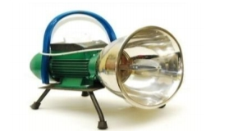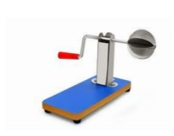**

**FIG (1): -** TRADITIONAL SCRAPER **FIG (2): -** ELECTRIC SCRAPER

**1.1 Types of scrapers designed in ancient days at various places: -**

#### C:\Users\MONA\Desktop\Screenshot_2019-06-05-22-22-26-361_cn.wps.moffice_eng.png

FIG (3)

1. Fig (3) shows a small carved rat from Thailand with a skillfully formed tongue scraper and lidded box in the back for an unknown purpose. In Thailand the carving and decoration are most often in the form of a stylized animal.

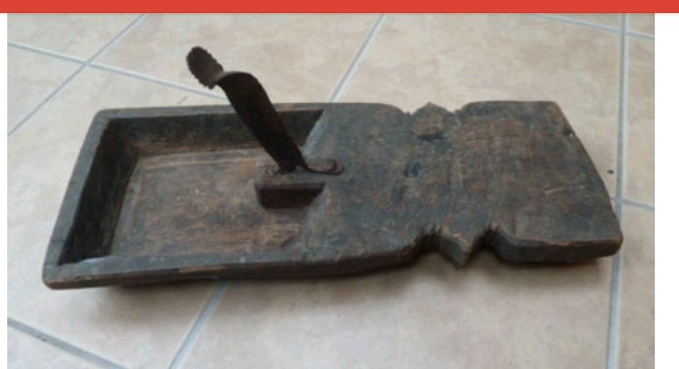

FIG (4)

1. Fig (4) shows the Keralan peeta, the wood carving is rather coarse, there are adze marks on the surface or they could cleaver marks from the surface being used as a chopping surface, quite a common fate for these objects.

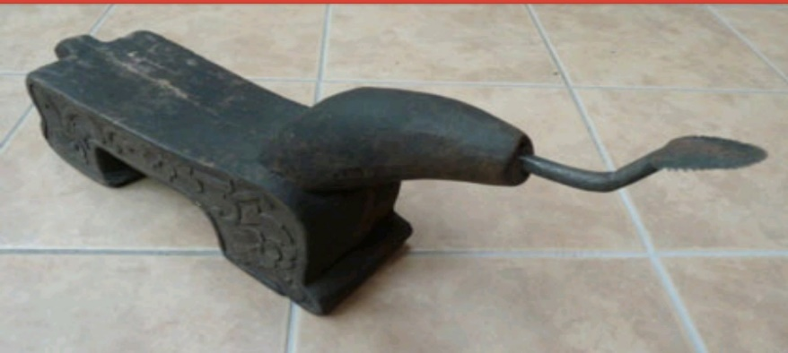

FIG (5)

* + - Fig (5) shows the malay coconut scraper is finished with a dark wood dye to highlight the carved side panels and also some carved detail around the base of the neck.

# CHAPTER 2 LITERATURE REVIEW

* **Kedar Deokar etal (2014): -**  He as proposed the design and manufacturing of coconut de-husking, cutting and grating machine consists of three operations, namely: Peeling of coconut fibers i.e. de-husking of coconut, breaking the coconut into two parts i.e. cutting and grating of coconut i.e. removing out the copra. For de-husking process, the method selected for removing the fibers is the opposite movements of toothed shafts whose spiked pins are inserted into the fibrous layer of coconut for its removal. If copra is the desirable product, then it will be sent to cutting process where it will be cut into two halves. After this, grating will be executed. Sub-assemblies of each operation are made separately to test the working of each process without any interference.
* **Ketan K. Tonpe etal (2014):** - have discussed about the coconut de-shelling machine comprising of cutter with belt drive. Performances test analysis conducted show that the machine de-shelled the fruits without nut breakage and also that its average de-shelling efficiency and capacity are 90% and 195 coconut per hour. The machine also eliminated dependency on the epileptic public electric power supply in our rural areas which constitutes the major obstacle in the use of other mechanized coconut de-shelling equipment in the rural area.

.

* **Jerry James etal (2016)**: - have described the proposed machine a Coconut Breaker Extractor Grater which can break a de-husked coconut into two pieces, collect coconut water and grate the coconut pieces into desiccated coconut. The main highlight is that there is no contact between the tool and hands of the user both in breaking and grating of the coconut.
* **Naveen J etal (2016): -** have discussed about the design and fabrication of a machine that can perform the operations such as grinding rice flour, vegetable cutting and coconut scrapping. It requires no special skills to operate the machine and would help the society in a better way by reducing the time and also the number of labours.

**2.1 Existing technology: -**

The problem with all these designs is that someone should hold the coconut near the blade all the time. Also scraping coconut using these machines are really time consuming and laborious. Also there is less safety while using these scrappers. The innovative design of the grating machine presented here solves all the above problems.

**2.2 Disadvantages of existing technology: -**

* There is no safety.
* These are time consuming.
* We should hold the coconut manually.
* The difficulty in storage.



**PROJECT WORK SCHEDULE**

|  |  |  |
| --- | --- | --- |
| Sl.no | Month | process |
| 1 | AUG-SEP | Selection of project topic(area) and submission of synopsis |
| 2 | SEP-OCT | Designing of Model |
| 3 | OCT-NOV | 3D modelling |
| 4 | NOV-DEC | Material collection, Preparation of temporary Model |
| 5 | JAN-FEB | Main parts assembly and Fabrication |
| 6 | FEB-MAR | Preparation of project report, inspection |
| 7 | MAR-APR | Trailing of model. |
| 8 | APR-MAY | Project presentation & Demonstration. |

**Introduction: -**

**CHAPTER 3**

**DESIGN PROCES**

The engineering design process is a methodical series of steps that engineers use in creating functional products and processes. The process is highly iterative parts of the process often need to be repeated many times before another can be entered though the parts that get iterated and the number of such cycles in any given project can be highly variable. Different authors define different phases of the design process with varying activities occurring within them.

### Steps Involved in design process

* **Problem identification**

Coconut scraper are time consuming, laborious have less safety as people needs to hold.

* **Problem definition**

People need easy, safe and quick way to grate coconuts.

* **Design objective**

Design should be safe, useful, portable, affordable and user friendly.

* **Design function**

The scraper should grate the coconuts in an efficient manner.

* **Design means**

Electricity, motor, blades.

# 2D DESIGN

# C:\Users\MONA\AppData\Local\Microsoft\Windows\INetCache\Content.Word\IMG-20190606-WA0016.jpg

# CHAPTER 4

**DESIGN METHODOLOGY AND SPECIFICATIONS OF COMPONENTS**

## Objectives of Our Project

The main objectives of the coconut scraping machine are as follows: -

* The design must be simple and compact.
* The weight of the machine should be less.
* It should reduce the human effort.
* The construction of the design is rigid.
* The coconut scrape rate should be more.
* The construction of the machine should be safer.

### 4.2 Components Used for the Project

1. **Motor: -** The motor produces torque that in terms used to rotate the scraper tool.

The motor is fixed in the tool head on the T-slot of the machine.

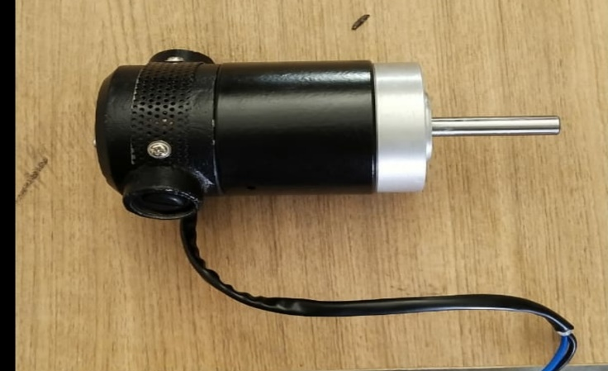

Fig(1): - Motor

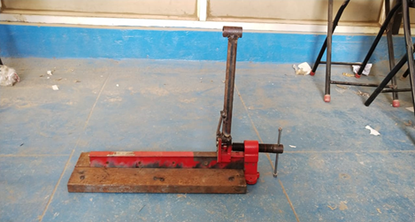

Fig(2): - T-SLOT

1. **T-SLOT: -** The above figure shows the T-slot which is made up of mild steel and it is mounted on the base, it provides movement of the holder head.

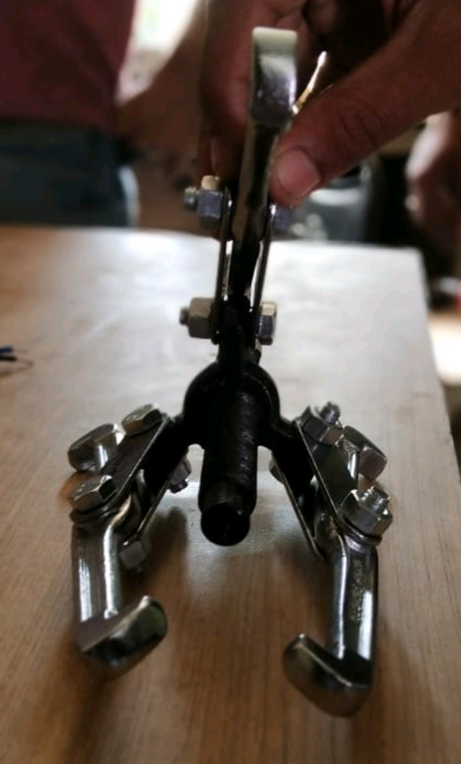

Fig(3): - coconut holder

1. **COCONUT HOLDER: -**  The above figure shows the coconut holder which is made up of

Stainless steel. This is used to hold the coconut tightly and provides liner feed to the coconut.

This is mounted on T-slot.

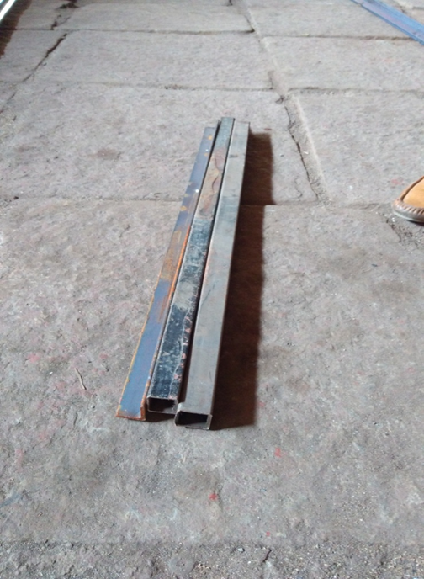

Fig(4): - Base

1. **BASE:** - The above figure shows the base of the machine that it is made up of mild steel. All the components are mounted on the base/support.

## MATERIAL CHART

|  |  |  |  |  |
| --- | --- | --- | --- | --- |
| **SL.NO** | **PARTS** | **MATERIALS** | **SPECIFICATIONS** | **QUANTITY** |
| **1** | Motor | - | DC ,1000 RPM  240V | 1 |
| **2** | T- Slot | Cast iron/Mild steel | - | 1 |
| **3** | holder | Stainless steel | - | 1 |
| **4** | Base | Mild steel | - | 2 |
| **5** | collector | sheet metal | - | 1 |

**CHAPTER 5**

**FABRICATION AND WORKING PRINCIPLE**

**5.1 Working principle: -**

Coconut scraping machine consist of a coconut holder, scraper, motor, collecting tray etc.

Place a half part of coconut in 3 jaw coconut holder and tighten the handle to fit the coconut.

In the holder. Plug the motor switch to the current supply. Switch ON the power button.

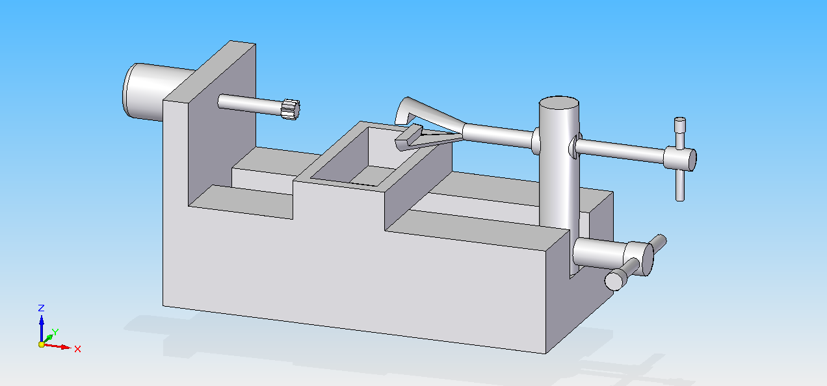When motor starts to rotate feed the coconut to the rotating scraper. Move or rotate the coconut holder to remove the coconut part inside it. Work until remove of all coconut inside it. After all is removed take back the feed of coconut holder. Switch off the power supply. Repeat the same for remaining coconut to be scrapped.

Fig: 3D model

## FABRICATION AND ASSEMBLY

|  |  |  |
| --- | --- | --- |
| **STEPS** | **FABRICATION PROCESS** | **DESCRIPTION** |
| **1** |  | **Tool head:** motor and scraper tool mounted on it. |
| **2** |  | **T-Slot:** It carries the tool head and feed head and provides movement. |
| **3** |  | **Base-support:** It carries all the parts**.** |
| **4** |  | Assembly of tool head and holder with t -slot. |

**Assembly of scraping machine**

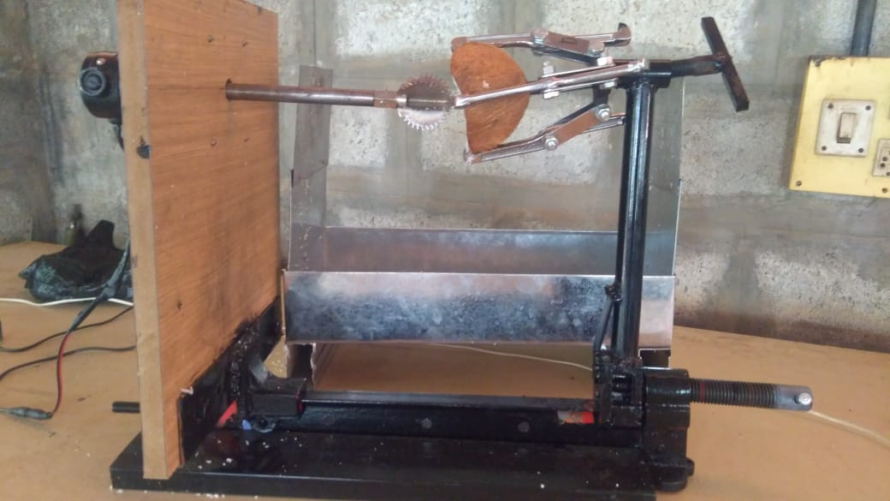

Fig: - Assembly of scraping machine

# CHAPTER 6

## FEATURE DEVELOPMENTS

* + 1. The coconut scraping machine must be fully automated.
    2. The coconut feeding must be automatic.
    3. Increase the coconut scrape rate with minimum time.

## APPLICATIONS

* + 1. Coconut powder making industries.
    2. This is widely used in food industries.
    3. It is also used in restaurants, hotels and home also.
    4. It is also used in coconut milk extracting industries.

## ADVANTAGES

1. It is a simple design.
2. It reduces the manually effort.
3. It reduces the time.
4. It provides the fine scraped coconut as desired.
5. It reduces human accidents.
6. It is compact in shape and size.

## DISADVANTAGES

1. The must be given manually.
2. It is compact in shape and size.
3. It is compact in shape and size.

# CHAPTER 7 BILL OF MATERIALS

|  |  |  |
| --- | --- | --- |
| **SL.NO.** | **MATERIAL** | **COST** |
| **1** | Metallic frame | 2000 |
| **2** | motor | 1000 |
| **3** | plywood | 300 |
| **4** | Shafts | 1000 |
| **5** | Sheet metal | 1500 |
| **6** | Holder stainless steel | 1000 |
| **7** | T - slot | 1000 |
| **8** | Other parts | 2200 |
|  | TOTAL | 10000 |

**CHAPTER 8 CONCLUSION**

Finally, the coconut scraping machine project is successfully done and it reduces the working time and man power. It is very useful for household and for commercial purpose. It fulfils the all requirements of food industries with the minimum cost.

.

The innovative coconut grating design is really time saving, less power consuming, safe and cost effective. It can grate coconuts within seconds. The only power it consumes is for rotating the motor. Also it is portable and simple. The coconut will be scraped completely. The materials used for making this machine are safe and long lasting.

# CHAPTER 9 REFFERENCES

* 1. Ghosh. B.N. (1967). “The power requirement of a rotary cultivator”. J.Agric. Engg. Res., 12(1): 5-12.
  2. A. Sadiq, Design and Engineering (Phasor Books, 2016).
  3. Clive L Dym, Patrick Little and Elizabeth J, Engineering Design (Wiley, 2015).
  4. R. Rajesh Kumar and Arun Mohan, Design and Engineering (Jyothis Publishers, 2016).
  5. Voland, Engineering by Design (Pearson, 2012).
  6. E.N.Anil Kumar, A.Anshadh and Bharath Krishna, Workbook on Design and Engineering (Vector Publications, 2016).
  7. J.Naveen , A Manikandan, P Maheshkumar, M.Selvaraj,”Design And Fabrication Of Low Cost Multi-Purpose Kitchen Equipment” International Journal of Engineering Research-Online,IV(4),pp.,2016.
  8. Jerry James, Jacqwin Joy, AbinShaji, Basil Chandy, Vinay Mathew John, “Design & Fabrication of Coconut Breaker, Extractor Grater Machine”, International Journal for Innovative Research in Science & Technology, II (11), pp., 2016.
  9. KetanK.Tonpe, Vinod P.Sakhare, C.N.Sakhale ,“Design & Performances of Coconut De-Shelling Machine”, International Journal of Engineering Research and Applications, IV(7),pp., 2014.